SOP = (~A\*~B)+(~A\*B)+(A\*~B)

Sum = A XOR B

Carry= A \* B

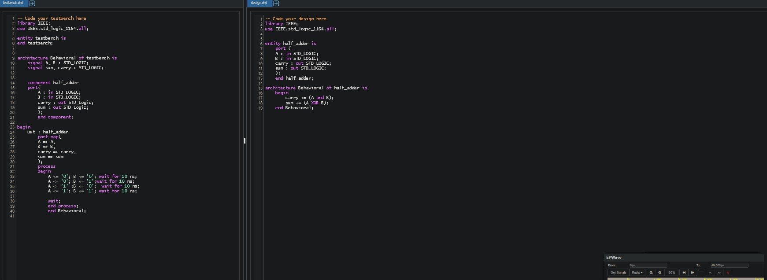

SOP Sum = (~Cin \* ~A \* B) + (~Cin \* A \* ~B) + (Cin \* ~A\* ~B) + (Cin \* A \* B)

SOP Cout = (~Cin\* A\*B) +(Cin \* ~A \* B) + (Cin \* A\*~B)+ (Cin \* A\*B)

Cout = (A and B) or (B and Cin) or (A and Cin)

Sum = (A XOR B XOR Cin)

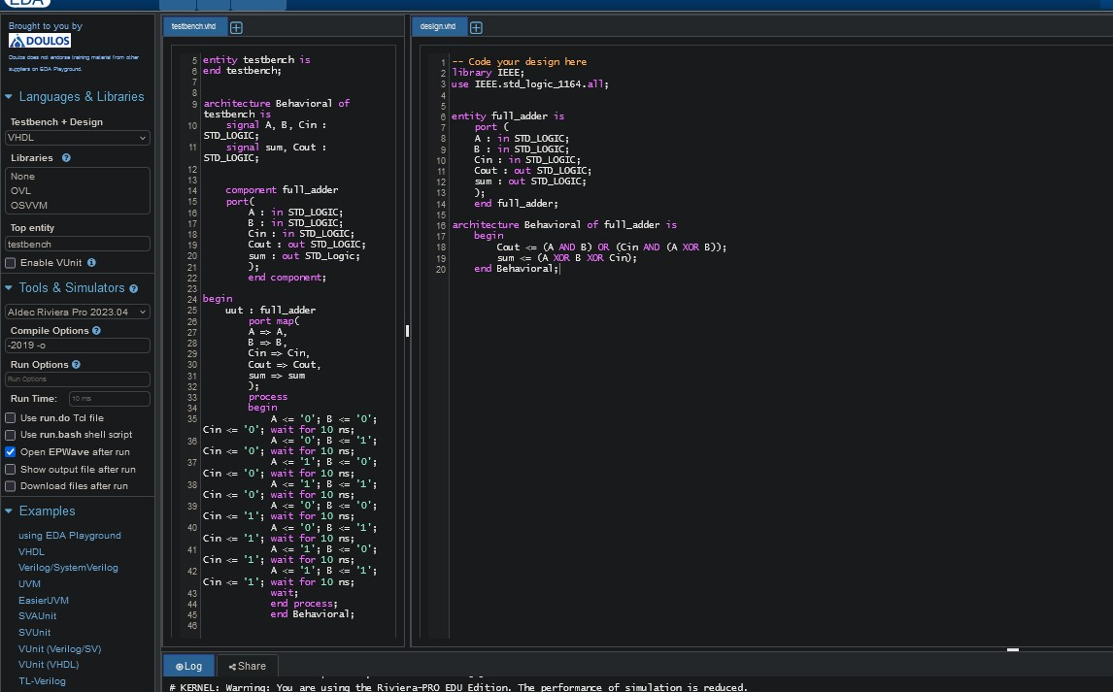

SOP Diff = (~B \* A) + (A\*B)

SOP Borrow = (~B\*A)

Borrow = A XOR B

Diff = ~A AND B

